**EMCC CONNECT DAY IS QUICKLY APPROACHING!**

**Wednesday, March 25, 2020**

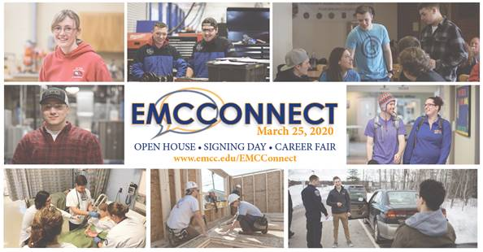

What is **EMCC CONNECT DAY**? It is a day to

* Celebrate our newly admitted students (SIGNING DAY)
* Highlight our programs (OPEN HOUSE) to potential future students, and
* Promote our current students to our partner employers through program demonstrations, career fairs, career panels and many more activities

What can you do to participate in **EMCC CONNECT DAY**?

* Attend the SIGNING DAY activities in Maine Hall rooms 117-120 at 9:00 a.m. – we would love all of our employees and students to celebrate EMCC’s newest students!
* Participate in telling our EMCC story to those interested in our career and technical and liberal studies programs
* Prepare student and faculty demonstrations, activities, panels, partnership events, and career fairs in your program area for our newly signed students, their families and our business and industry partners
* Welcome our sponsors and vendors as they participate to support our students and EMCC

What will **EMCC CONNECT DAY** look like?

* 9:00 Gather in Maine Hall rooms 117-120 to cheer on new EMCC students!
* 11:00 – 1:30 All current, new, potential students go to their program of study for student and faculty demonstrations, or panels, career fairs etc. Several GRAB & GO lunch areas will be set up
* 1:30 – 2:30 All students have options for college tours, transfer fair, on-the-spot admissions and fun activities!

This is going to be a fantastic day to celebrate our students, inform and recruit students, engage with our business and industry partners, and tell our story. I appreciate the team helping to prepare for this event. It Is the biggest truly comprehensive college event we have created in the last several years. It is a great opportunity to highlight our programs and campus and all we have to offer. I look forward to seeing you all there.

Additional and supporting information will be sent out, via email and the college newsletter as well as department meetings. Please let your supervisor know if you have further questions or ideas.

**ACEN Nursing Accreditation Achieved**

The Accreditation Commission for Education in Nursing was on campus Wednesday, Thursday, and Friday of this week. The great news is that the Nursing Program has received continuing accreditation status for the next 8 years. While the program is in compliance with all six standards, there are also a few recommendations. The evaluators were very impressed with the faculty, noting the strong bond among them and the art of mentoring that is taking place with the newer faculty. Nicely done! They also noted that the relationship between the faculty and the students was very positive – something they had not seen at other campuses. Thank you Pilar, Mary Ellen, Connie, Heather, Sally, Vanessa, Beth and Jessica! I did not get a photo of Pilar as she concluded the visit – but she was all smiles! Congratulations!!



**IMS Global Conference**

A few weeks ago, I attended the IMS Global conference with Megan London. IMS Global is a collaborative advancing edtech interoperability, innovation, and learning impact. They support initiatives around digital credentials and pathways, learning data and analytics, integrated assessment, learning platform apps and tools, and adaptive digital curriculum.

Megan, along with partners from the MCCS System, Department of Corrections, and the UMaine System presented on the Lumina Foundation grant work, All Learning Counts. Eastern Maine Community College represents the system in this grant. Our focus has been the development of the Opportunity Badge that focuses on preparing individuals to be Life Ready, Education Ready, and Career Ready. The Life Ready micro-badge is currently offered to offenders at the Mountain View Correctional Facility. We are also partnering with several high schools to provide the Opportunity Badge and some EMCC faculty are integrating the Life Ready micro-badge into their courses.

Megan’s team were great in sharing information on the badge, its development, and the pilot project (Mountain View) successes and challenges and how it will impact the Lumina grant work.

Mike Preble will be transitioning to the Curriculum Designer position as Megan has accepted the full-time Education faculty position at the college. Thank you, Megan!

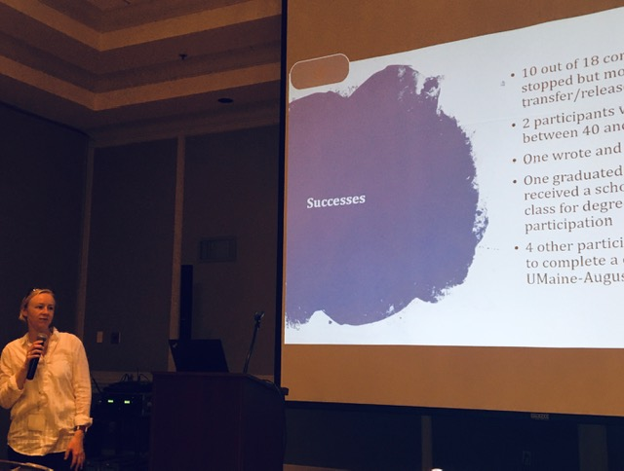

**Legislative Update**

Becky Smith, Director of Government & Community Relations has shared there are 5 bills, in play, related to higher education. They focus on:

* Public institutions with construction projects be required to purchase American made products and services
* Programs that include outdoor excursions, camping etc. be required to use Maine Guides
* All public higher education institutions use one financial aid form/communication with students
* Support college completion by homeless youth through housing resources and other assistance
* Increase higher education waivers for kids in the foster care system

Becky will provide updated information as it becomes available. She may also request information directly to help legislators understand the impact of these bills etc. More to come.

The Maine Community College System provided information and partnership testimony related to our requests currently in the Governor’s supplemental budget that provides $1.7 million for continuing operations and $5 million in workforce training funds. There is great support for the system and 7 colleges but there has been no decision to date.

**Negotiations Update**

All of the bargaining unit negotiations have been settled, including adjunct faculty. It is anticipated that over the next several years, all colleges will have consistent adjunct rates. Each college will begin planning for these changes in the FY21 budget planning process. We are reviewing the impact and will share with a budget update in the next few weeks.

**Bookstore RFP**

The System Finance Department issued an RFP for the college bookstore. The most recent RFP was completed three years ago. There are 2 vendors presenting their proposals, today, February 28th to college representatives at CMCC. It is anticipated a decision will be made in the next month.

**Master Facilities Plan Update**

The Strategic Program Alignment and Facilities Master planning process continues. The steering committee met in early February to discuss the information synthesized from the focus group meetings, facilities data, and workforce data. The group is scheduled to meet again on Wednesday, March 11th to share our feedback, review opportunities and begin to draft low, medium, and high priorities. We will share this information to the college timeline on the website.

**Upcoming Events to Put on your Calendar**

* **Thursday, March 12th** – 6 pm Phi Theta Kappa Induction, Rangeley Hall
* **Monday, March 16th** 3-5pm, Library in Katahdin Hall - Maine's Bicentennial Celebration Screening Maine Public Broadcasting Network's movie "Home" and student work
* **Thursday & Friday, March 19-20th – SKILLS USA on campus!**
* **Wednesday, March 25th – EMCC Connect Day!**