Summary – February College Forum notes:
I am sharing the information from yesterday’s College Forum that includes updates and a focus on the future of higher education at EMCC.
- Our slightly revised mission statement has been approved by the MCCS Board of Trustees. The revised mission states, “EMCC provides the highest quality post-secondary technical, career and transfer education and services, while serving as a community and economic development resource. The revisions include replacing the word “and” for “while” and taking out the word dynamic before community.

- The Methods of Administration/Office of Civil Rights visit has concluded. The Methods of Administration is a program supported by the Maine Department of Education and its focus is to ensure that all students have equal access to high quality career and technical education programs. It also oversees the civil rights compliance program. The process included two comprehensive visits, as well as review of our policies, processes, practices, and facilities. It was noted in our exit meeting last week that we are making progress on the facility recommendations, that we support students in meaningful ways including through the Accessibility Office, and that faculty and staff have the appropriate knowledge about processes and services. We will receive the final report in the next 4-6 months. Thank you to Terri Adam for managing the visits and providing the documentation, to the faculty and staff who met with our on-site evaluator, Danielle Despins. Kudos to George, Mike, Nate, and Bard for their continuing efforts to address the facility compliance requirements.

- Earlier this week, Governor Mills released her supplemental budget that included support for the Maine Community College System including 1.7 million for continuing operations and 5 million in workforce training funds. While it is early in the session, it is a short session. I will keep you updated.

- Please take a moment to welcome individuals to the college or to new/interim positions:

  - Melissa Boyan – Manager of Financial Services
  - Mike Preble – Curriculum Designer
  - Bill Cook – Interim Librarian through May and the search process
  - Glenna Washburn – Interim TRiO Tutor Coordinator as Jeremy White is welcoming his new baby
Thank you to Karen Shorette for her excellent work as the Manager of Financial Services for over 25 years. She is looking forward to ice fishing, great music and of course her grandson. I also want to thank Megan London in creating the framework for the Curriculum Designer position. Truly appreciate each of these individuals. We also wish Cynthia the best as she takes on a new role at the University of Maine, Augusta.

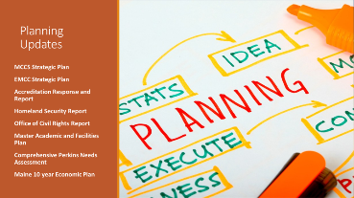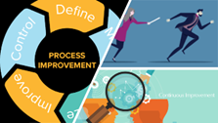

Planning:

We continue to update our planning timeline. It can be found on the EMCC website under the tab Mission & Vision page under Discover EMCC. I am also providing a link: https://www.emcc.edu/discover-emcc/overview/mission-vision/

We have added one new report and links to reports we will be adding soon. Our newest report is Maine’s 10 year Economic Plan that focuses on economic development strategy through collaboration and partnerships. It is a critical set of information that helps us think about the future of higher education and our role in this work. Reports that will soon be added include the Homeland Security report that was completed this last December, the Methods of Administration/Office of Civil Rights report, the Master Academic and Facilities Plan, and the Comprehensive Perkins Needs Assessment.

All of these plans, reports, and information will become part of a larger conversation around the needs of our students, employers, community, faculty and staff in the next five years and beyond.

In addition to these planning efforts, there are many initiatives around the campus that focus on transition and succession planning, process documentation and continuous quality improvement. Some of these conversations on the future of higher education and what structure we need to support our students is already happening.

There are als disruptions that impact our work and our thoughts about higher education. These disruptions tend to be events, situations both internal and external that affect how we think about our work, approach our work and organize our work. A few examples of discuptions I shared at yesterday’s forum inlucde:

- In 2000, there were 207,037 students in Maine K12; today there are 182,496 – a 12% decrease. There are fewer traditional students coming into higher education.
- There are 190,000 Maine adults who have begun but not completed a credential of value and probably have some debt.
- Over 30% of MCCS and UMS students are over 25 years old.
- Alsomost half of Maine public school students are conomiically and or academically disadvantaged.
- The number of companies offering their own training and credentials is increasing. Some examples include Amazon, Google, IBM and Cianbro.
- A Future Workplace survey of 600 employwers noted that 2/3 would hire candidates with a professional certification or a certificate of completion and 47% would hire a candidate with a MOOC degree. This same survey found that 40% of employers estimate that a skills is useable for about 4 years or less and more and more employees will require consistent upskilling.
I share these examaples as information. I am not making a value statement on our work or degrees. I have several degrees and believe strongly in the value degrees hold, rather it is a statement that we need to understand our enviironment to be prepared to respond to the changing needs of our students, our partners, and our community. I shared three quotes that forecast that change is here.
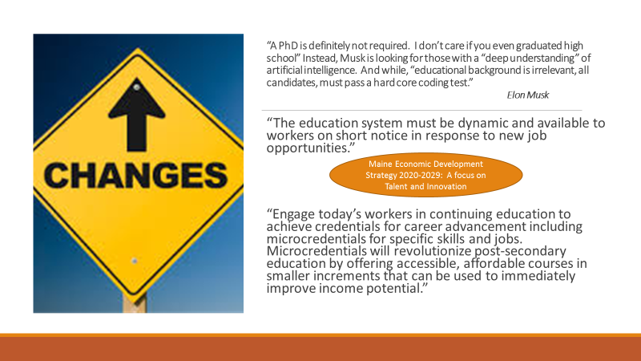
Given our planning documents, the changes we find ourselves in with retirements and transitions and the need for process and continuous improvement, it is also important to check in, reflect, connect, and engage to transform how we do our work to ensure we are achieving the results our students need. This has brought on more questions, such as
- How do we educate?
- Who do we educate?
- Where do we educate?
- When do we educate?
- Why do we educate?
- Have we included all of the critical stakeholders?
- Are we considering a variety of data and information?
- Are we measuring our success with the right instruments?
- Are we bold enough, creative enough and anticipatory enough to respond to these disruptions?
To address these and other questions, I am recommending we take the next 16 months to connect and engage to full realize the responses to these questions and to understand the roles and organizational structure we need to have to be successful. I also recommend that we use Design Thinking as a tool to move through thses conversations. Some of you may have an understanding of this tool and for some it may be new. We will be inviting anyone who is interested to learn more about Design Thinking and to participate in professional development through IBM on Design Thinking. Be on the lookout for an email from Nick Runco. We ask that you consider to participate as facilitators on the conversations that will take place next fall and spring. Here a draft set of phases for this work:
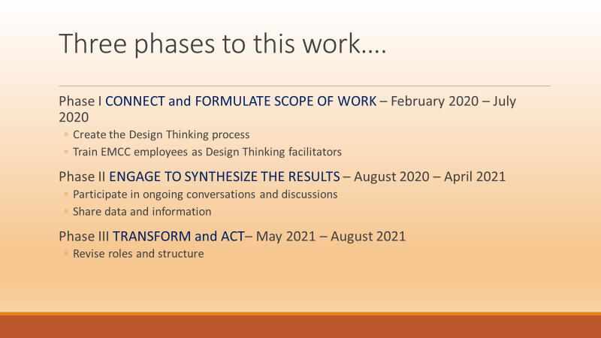

This is important work. We are preparing ourselves and the college to ensure future success. We will have succeeded if we create an organizational structure that endures and thrives through an ever-changing set of demands that helps us to achieve the results we need for our students. I appreciate your work, commitment, and focus on our students’ success.

