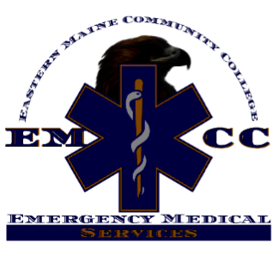
Paramedic Program Educational Outcomes
Class | NRP Cognitive Pass Rate | NRP Psychomotor Pass Rate | Retention Rate | Positive Job Placement Rate
Class of 2018 | 100% | 100% | 92% | 100%
Class of 2019 | 90% | 100% | 83% | 100%
Class of 2020 | 100% | 100% | 100% | 100%

Eastern Maine Community College’s Paramedic Program is accredited by the Commission on Accreditation of Allied Health Education Programs upon the recommendation of the Committee on Accreditation of Educational Programs for the Emergency Medical Services Professions (CoAEMSP).
Commission on Accreditation of Allied Health Education Programs (CAAHEP) 25400 U.S. Highway 19 North, Suite 158
Clearwater, FL 33763
www.caahep.org
Committee on Accreditation of Educational Programs for the Emergency Medical Services Professions (CoAEMSP)
8301 Lakeview Parkway, Suite 111-312
Rowlett, TX 75088
www.coaemsp.org

